PROJECT REPORT.

1.INTRODUCTION:

1.1 OVERVIEW:[E-COMMERCE DESCRIPTION]

MY PROJECT NAME IS E-COMMERCE:

The E-commerce: Shoe Store is a web application that provides the user to watch various shoes according to the categories like running, best performance shoes, etc. It allow users to move their shoes to the cart and accordingly shows how much items are their in there cart and shows price as well. Contains bootstrap items like carousels, cards, etc which can be helpful for and can be used to learn new things for future references.

1.2 PURPOSE:

An ecommerce website is your digital storefront on the internet. It **facilitates the transaction between a buyer and seller**. It is the virtual space where you showcase products, and online customers make selections. Your website acts as the product shelves, sales staff, and cash register of your online business channel.

2.LITERATURE SURVEY:

2.1 EXISTING PROBLEM:

One of the biggest Online Shopping Problem faced is security concerns. With cybercrime on the rise, consumers are becoming increasingly wary of sharing personal and financial information online. Hackers are constantly looking for vulnerabilities in e-commerce websites to steal customer data such as credit card information, addresses, and even login credentials. This can lead to identity theft and financial loss, which can be devastating for consumers.

1. Delayed Delivery.
2. Lack of Payment Options.
3. Complex Checkout Process.
4. Non-Mobile-Responsive Website.
5. Security

2.2 PROPOSED SOLUTION:

Fastrr: One-Stop Solution for All The Above Problems.

Fastrr is an efficient and frictionless end-to-end solution that helps businesses deliver the best customer experience from beginning to end. It offers the following benefits for businesses:

* **EDD (Estimated Delivery Date)**: Fastrr shows the estimated delivery date of the shipments to the buyers to keep the customers in the loop of their shipments and keep them informed of any delays.

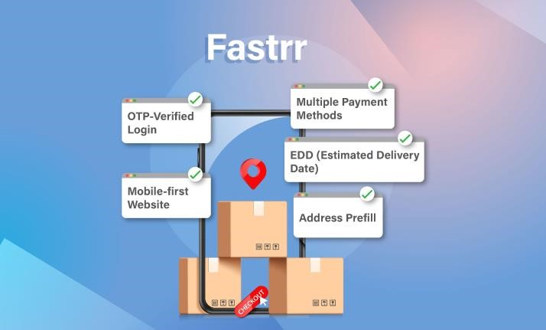

* **Multiple Payment Methods**: It offers multiple payment methods like UPI, COD, and several others to give customers flexible payment modes.
* **Address Prefill**: Fastrr uses three easy steps to give customers a quick and seamless experience from start to end.
* **Mobile-First Website**: A mobile-first website provides customers with an easy and seamless shopping experience.
* **OTP-Verified Login**: It uses OTP-verified login to avoid the hassle of passwords and provide a secure shopping experience to the customers.

3.THEORITICAL ANALYSIS:

* 1. BLOCK DIAGRAM:

**Technical Architecture:**

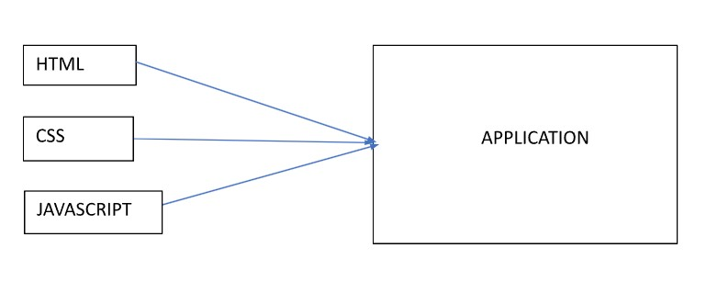

* 1. HARDWARE /SOFTWARE DESIGNS:

Hardware

Hardware is simple to access and obtain. Almost everyone has hardware in their home capable of helping them run a business. You must have quality equipment to successfully run a business and have a smooth startup process. The hardware you have will determine how easy your daily work is when running a small business. You need organization and the hardware needed will help you save money and time in the end.

1. External Hard Drive

Given that most things are done online these days it’s important to have some kind of hard drive to store information in. External hard drives keep your business organized and your information in a secure place. You must invest in this type of equipment to maintain a successful running business online and physically.

want to make sure you invest in security for theft cases.

1. Desktop/Laptop Computer

Everyone has one these days and it is crucial for any business who wants to grow and thrive to have a designated computer system. Make sure to invest in the equipment that will last and that is reputable for businesses. Finding a [computer or laptop](https://www.pcmag.com/roundup/264323/the-best-business-desktops) won’t be hard due to the fact that they are sold everywhere, along with much technical equipment.

1. Network Server

Network servers are highly important for fast and easy speeds and databases. You will have access to more storage capacity and higher security. For your business, you want to stay away from using your computers network server and get one that is specifically dedicated to your business only.

1. Mobile device

A mobile device is almost always necessary when running a business. There will be moments when you need to make professional calls and you don’t want to use your personal phone. Having a device that is specifically for your business helps with organization and professionality. From tablets to cellphones, its good to have a mobile device that you can take anywhere and handle business situations easily and conveniently. There are certain mobile devices that work for business purposes:

* iPhone
* Samsung Galaxy
* CAT S41
* Kyocera Brigadier
* LG X
* Samsung Galaxy Tablet
* Apple iPad
* Getac F110

4.RESULT: 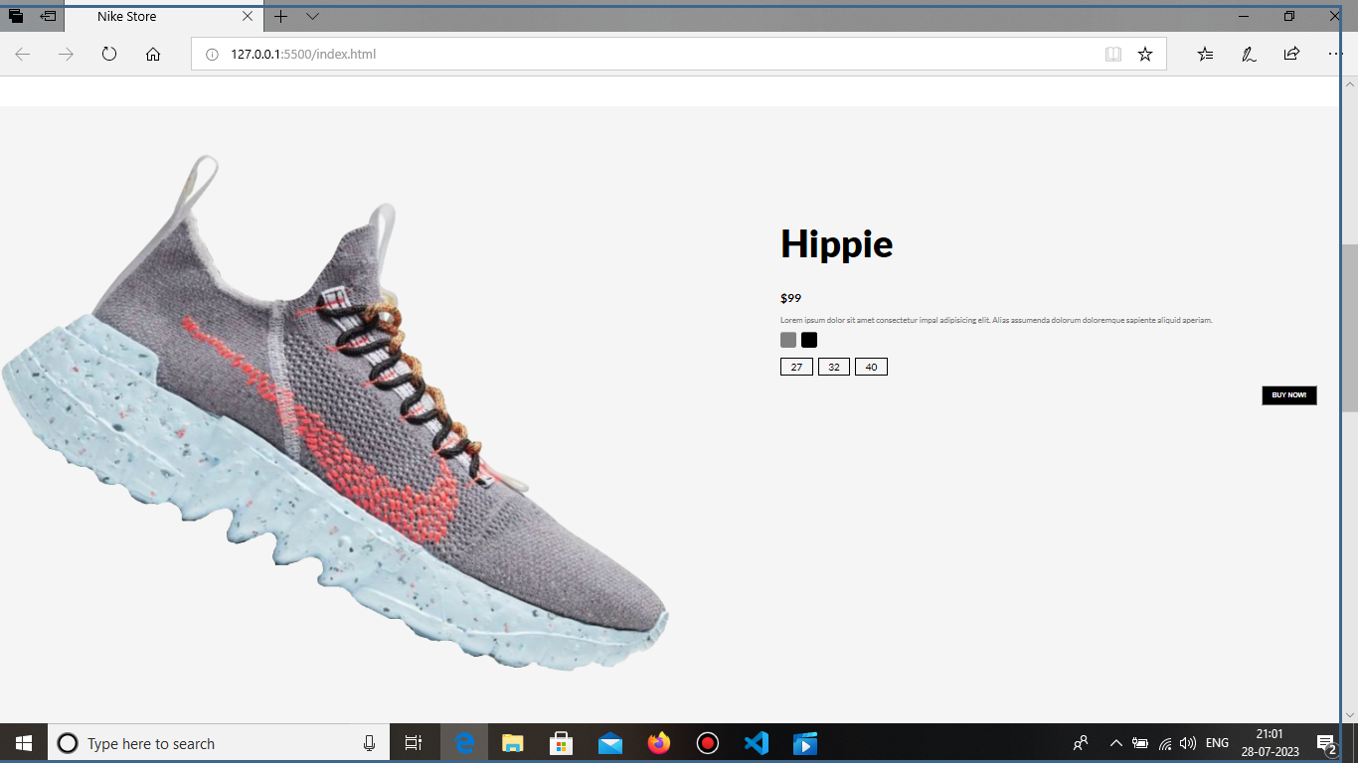

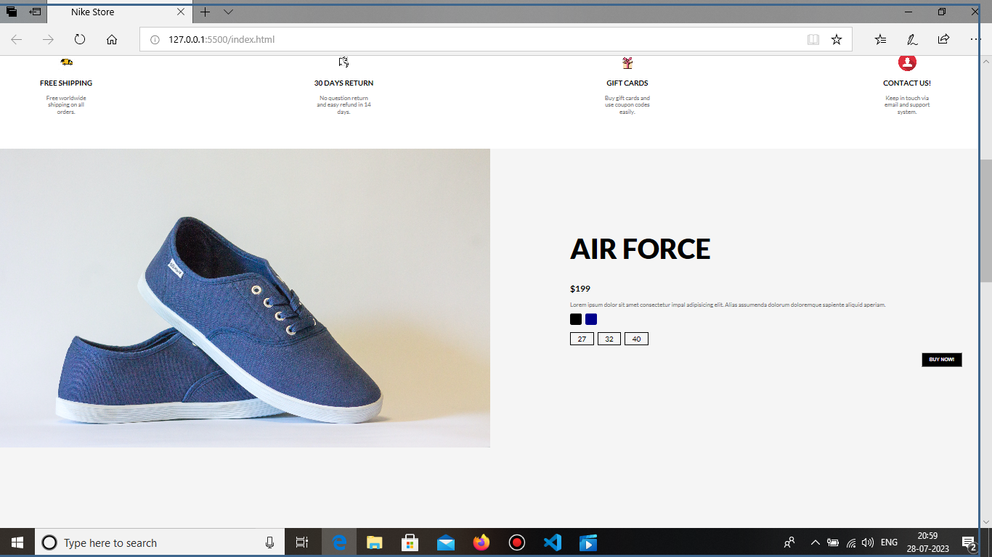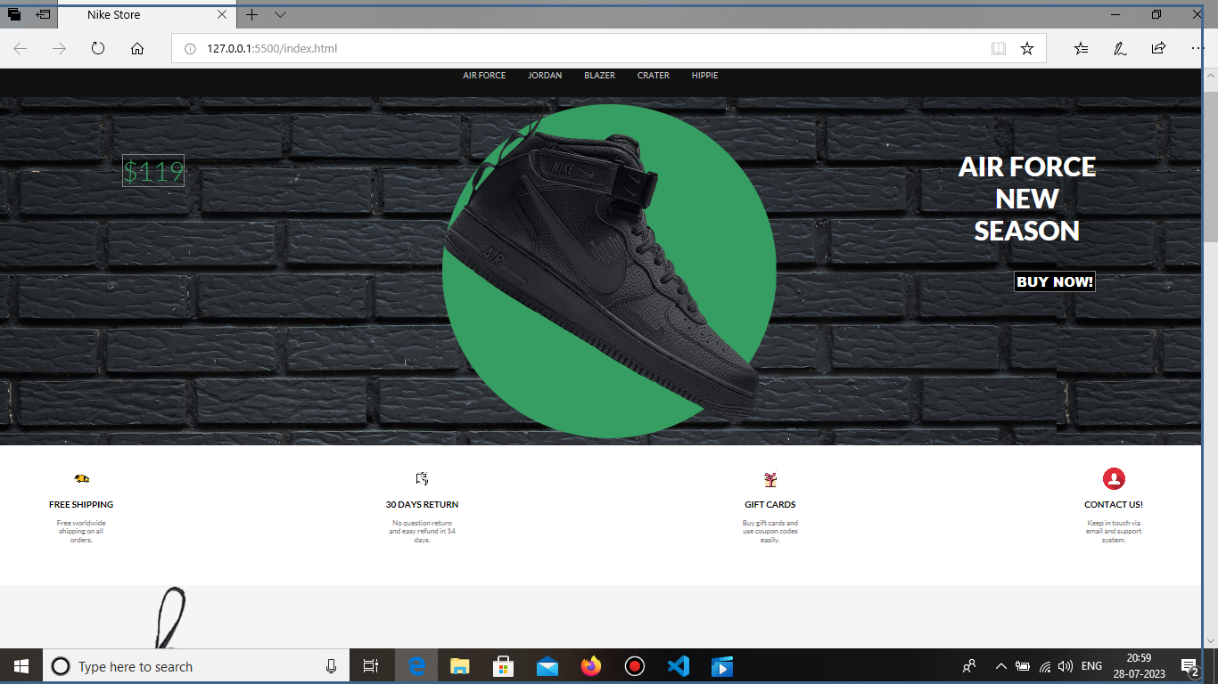

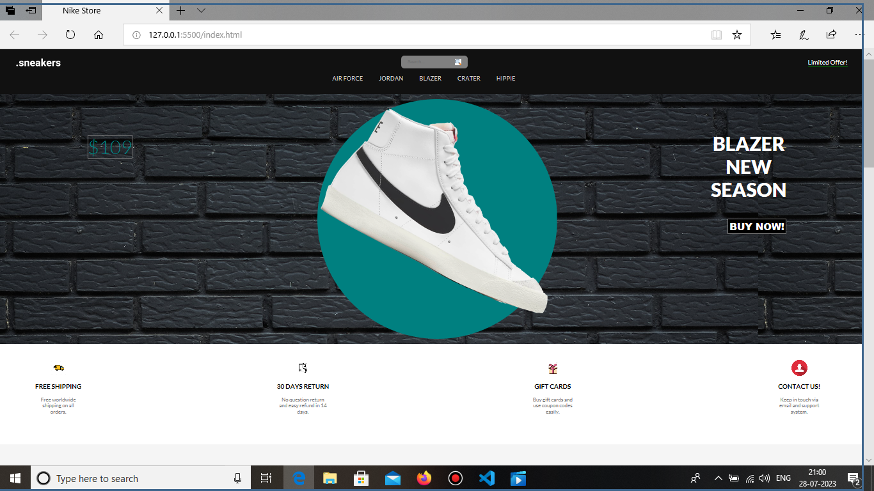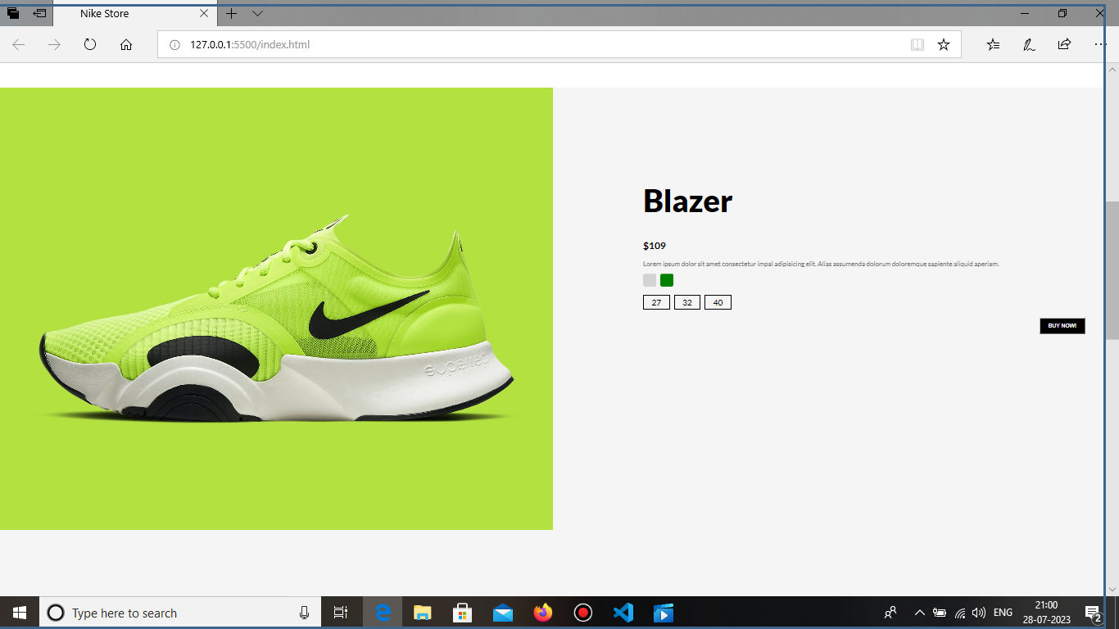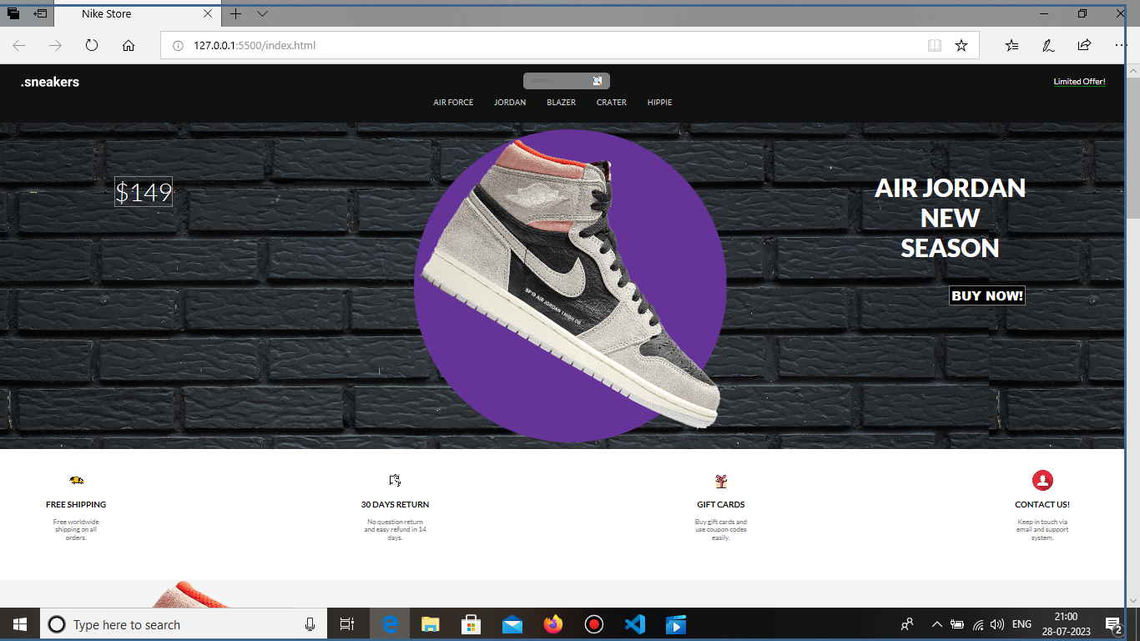

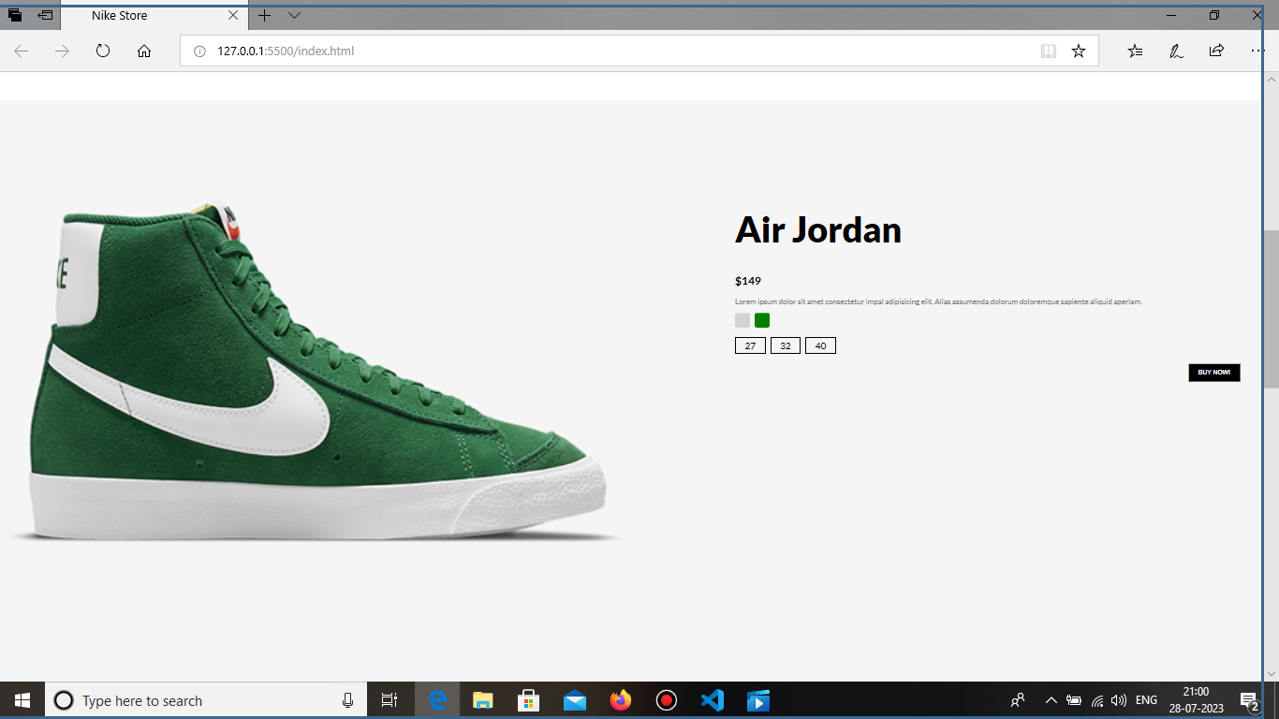

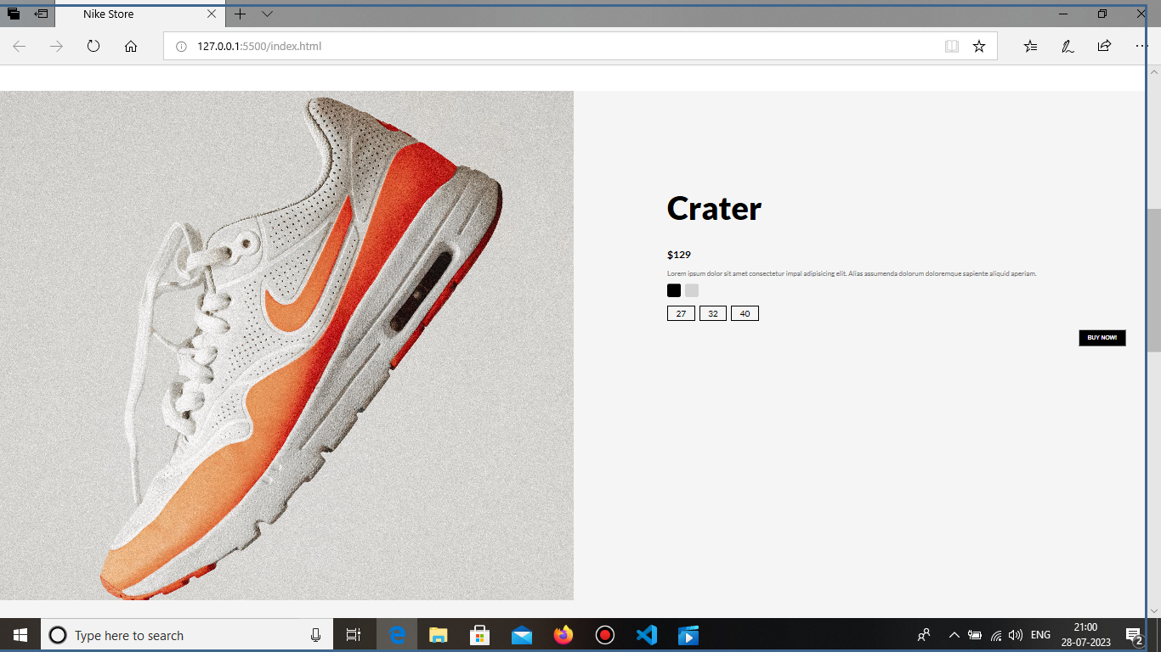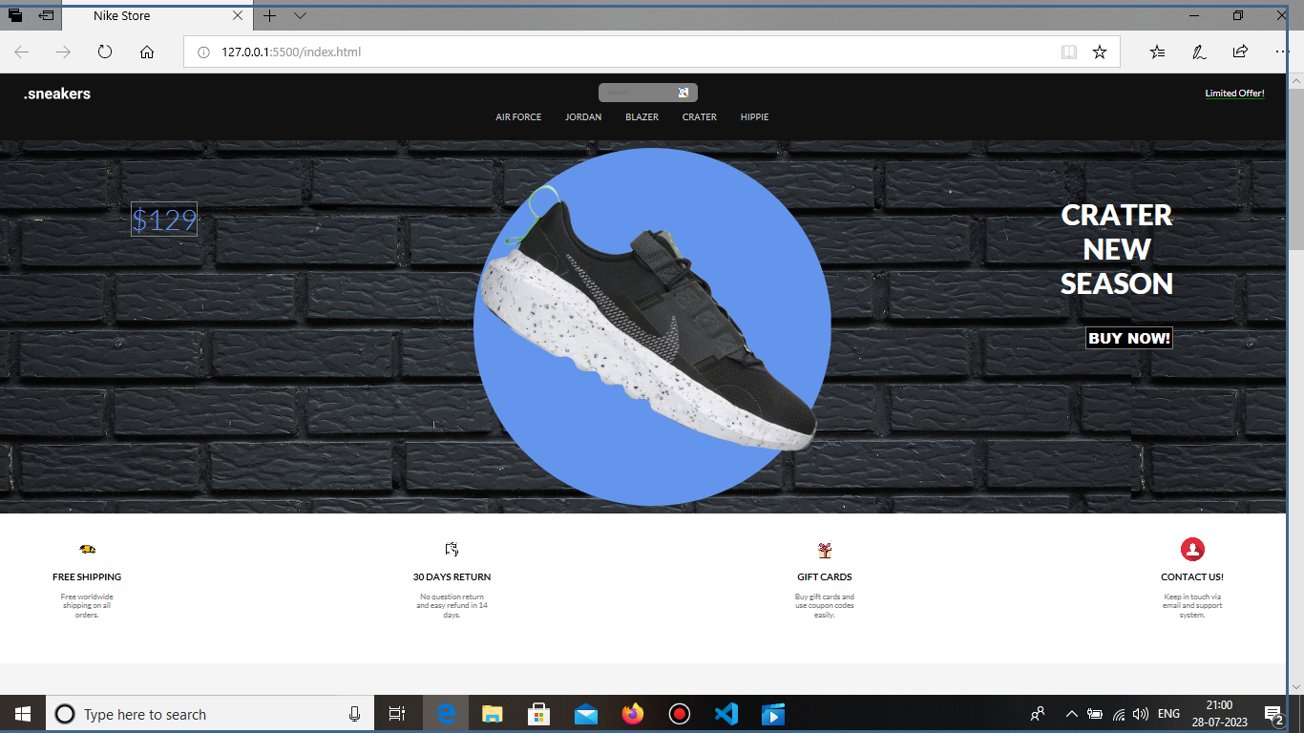

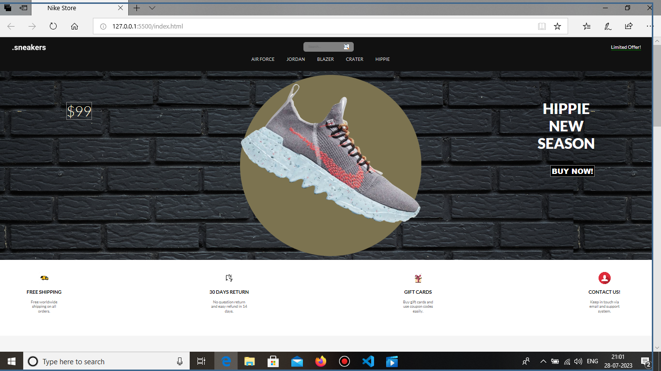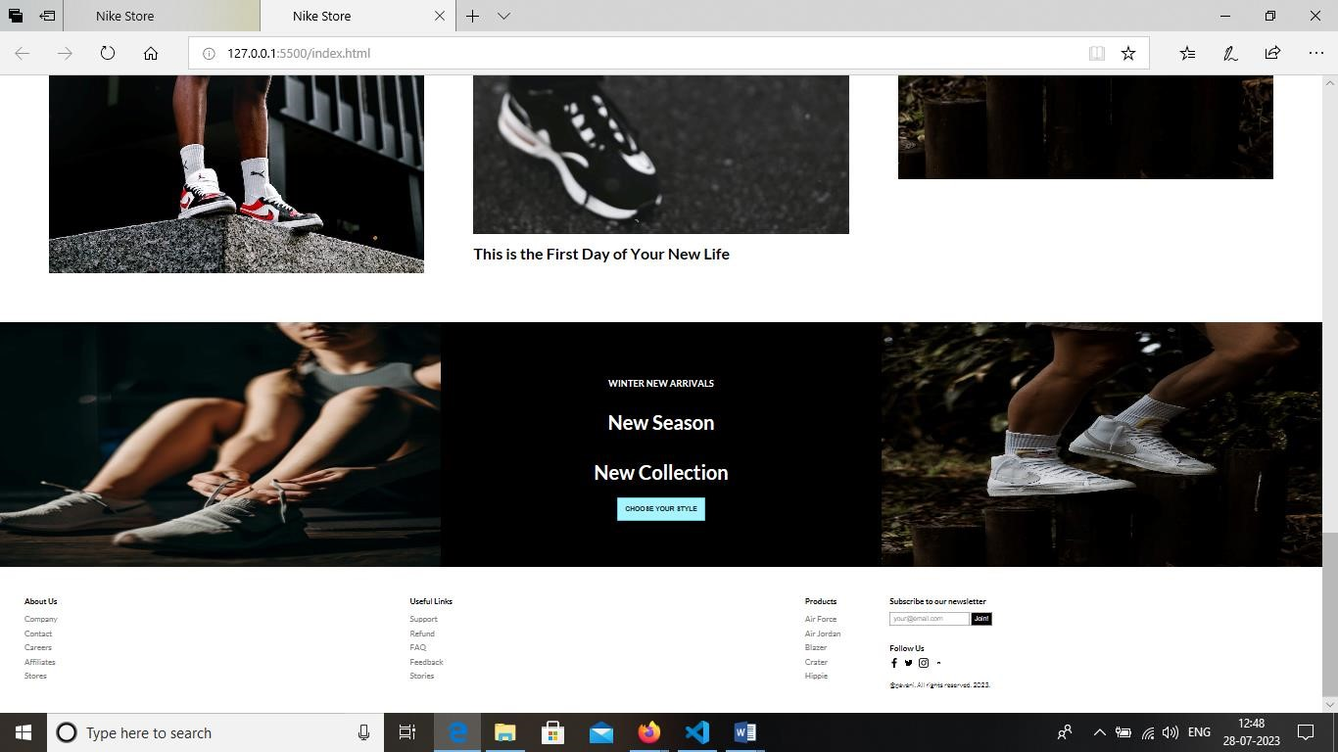5.ADVANTAGES AND DISADVANTAGES :

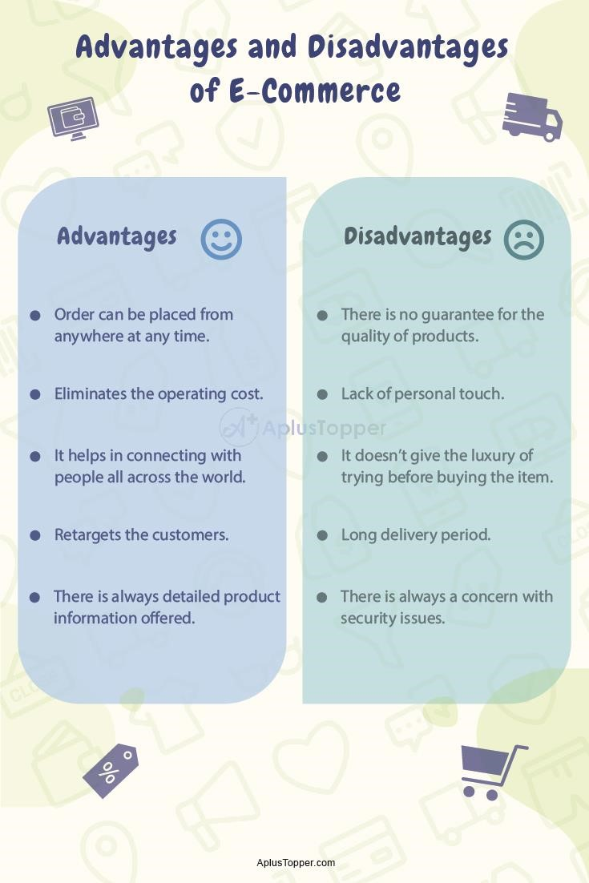

6.APPLICATIONS:

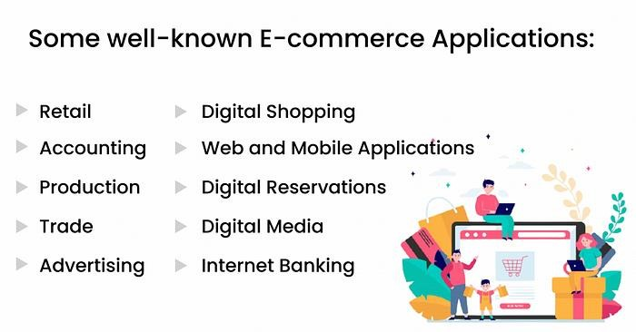

7.CONCLUSION:

The E-commerce: Shoe Store is a web application that provides the user to watch various shoes according to the categories like running, best performance shoes, etc. It allow users to move their shoes to the cart and accordingly shows how much items are their in there cart and shows price as well.

8.FUTURE SCOPE:

**More and more businesses will enter the e-commerce industry, and the scope for new products is higher because of the brands' growing understanding of the customers**. Available market research is helping soon-to-launched brands curate products that meet the needs of new-age customers.